Rebond atmosphérique

Table des matières
Rebond atmosphérique 1
Introduction 2
Post-war development 3
Missile use 3
Reentry vehicle use 4
Flight mechanics 4

Introduction
Le rebond atmosphérique ou rentrée atmosphérique par ricochets (en anglais : boost-glide, « boost plané ») est un type de trajectoires de guidage et de rentrée atmosphérique d'engins spatiaux qui recourt à la portance aérodynamique dans la haute atmosphère. Il permet d'étendre la portée des avions spatiaux suborbitaux et des véhicules de rentrée.
Dans la plupart des exemples, les rentrées planées permettent à peu près de doubler la portée par rapport à la trajectoire purement balistique. Le rebond atmosphérique, en enchaînant plusieurs sorties puis rentrées atmosphériques, permet d'étendre davantage la portée. On parle alors de « plané sauté » (skip-glide) ou de rentrées par ricochets (skip reentry).
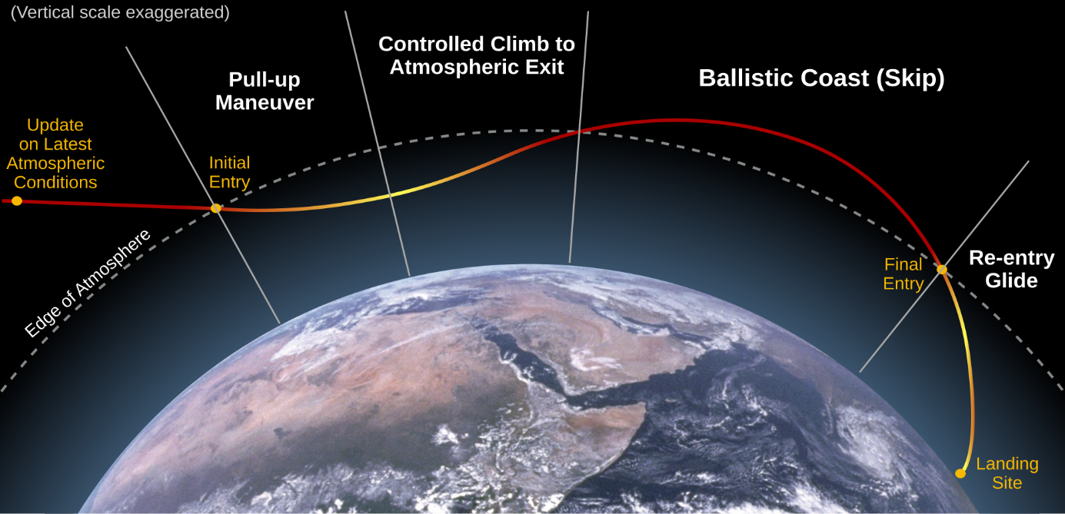
.
Le concept a d'abord été sérieusement étudié comme moyen d'étendre la portée des missiles balistiques, mais n'a pas été utilisé de manière opérationnelle sous cette forme car des missiles conventionnels à portée étendue ont été introduits. Les concepts aérodynamiques sous-jacents ont été utilisés pour produire des véhicules de rentrée manœuvrables (en anglais : maneuverable reentry vehicle, MaRV) ou des planeurs hypersoniques, pour augmenter la précision de certains missiles comme le Pershing II ou pour éviter l'interception comme dans le cas de l'Avangard. Plus récemment, ces techniques d'extension de portée ont été utilisées pour produire des vols à des altitudes plus basses que les missiles balistiques (qui sortent de l'atmosphère), permettant ainsi d'éviter plus longtemps la détection par radar au sol, celle-ci étant limitée par l'horizon-radar dû à la courbure de la Terre, problème corrigé partiellement par des radars trans-horizon ou des satellites.
Le concept a également été utilisé pour allonger le temps de rentrée des véhicules revenant sur Terre depuis la Lune, qui auraient sinon subi une décélération très brutale associée à des échauffements extrêmement élevés. Le module de commande et de service Apollo a recouru à une rentrée à un saut partiel (portance permettant de rallonger la trajectoire mais sans sortie de l'atmosphère), alors que les Zond soviétiques, la sonde chinoise Chang'e 5 et son démonstrateur Chang'e 5-T1 ont effectué un saut complet.

Post-war development
In the immediate post-war era, Soviet rocket engineer Aleksei Isaev found a copy of an updated August 1944 report on the Silbervogel concept. He had the paper translated to Russian, and it eventually came to the attention of Joseph Stalin who was intensely interested in the concept of an antipodal bomber. In 1946, he sent his son Vasily Stalin and scientist Grigori Tokaty, who had also worked on winged rockets before the war, to visit Sänger and Irene Bredt in Paris and attempt to convince them to join a new effort in the Soviet Union. Sänger and Bredt turned down the invitation.
In November 1946, the Soviets formed the NII-1 design bureau under Mstislav Keldysh to develop their own version without Sänger and Bredt Their early work convinced them to convert from a rocket powered hypersonic skip-glide concept to a ramjet powered supersonic cruise missile, not unlike the Navaho being developed in the United States during the same period. Development continued for a time as the Keldysh bomber, but improvements in conventional ballistic missiles ultimately rendered the project unnecessary.
In the United States, the skip-glide concept was advocated by many of the German scientists who moved there, primarily Walter Dornberger and Krafft Ehricke at Bell Aircraft. In 1952, Bell proposed a bomber concept that was essentially a vertical launch version of Silbervogel known as Bomi. This led to a number of follow-on concepts during the 1950s, including Robo, Hywards, Brass Bell, and ultimately the Boeing X-20 Dyna-Soar. Earlier designs were generally bombers, while later models were aimed at reconnaissance or other roles. Dornberger and Ehricke also collaborated on a 1955 Popular Science article pitching the idea for airliner use.
The introduction of successful intercontinental ballistic missiles (ICBMs) in the offensive role ended any interest in the skip-glide bomber concepts, as did the reconnaissance satellite for the spyplane roles. The X-20 space fighter saw continued interest through the 1960s, but was ultimately the victim of budget cuts; after another review in March 1963, Robert McNamara canceled the program in December, noting that after $400 million had been spent they still had no mission for it to fulfill.

Missile use
Through the 1960s, the skip-glide concept saw interest not as a way to extend range, which was no longer a concern with modern missiles, but as the basis for maneuverable reentry vehicles for ICBMs. The primary goal was to have the RV change its path during reentry so that anti-ballistic missiles (ABMs) would not be able to track their movements rapidly enough for a successful interception. The first known example was the Alpha Draco tests of 1959, followed by the Boost Glide Reentry Vehicle (BGRV) test series, ASSET and PRIME.
This research was eventually put to use in the Pershing II's MARV reentry vehicle. In this case, there is no extended gliding phase; the warhead uses lift only for short periods to adjust its trajectory. This is used late in the reentry process, combining data from a Singer Kearfott inertial navigation system with a Goodyear Aerospace active radar. Similar concepts have been developed for most nuclear-armed nations' theatre ballistic missiles.
The Soviet Union had also invested some effort in the development of MARV to avoid US ABMs, but the closure of the US defenses in the 1970s meant there was no reason to continue this program. Things changed in the 2000s with the introduction of the US's Ground-Based Midcourse Defense, which led Russia to reanimate this work. The vehicle, referred to as Object 4202 in the Soviet era, was reported in October 2016 to have had a successful test. The system was revealed publicly on 1 March 2018 as the hypersonic glide vehicle (HGV) Avangard (Russian: Авангард; English: Vanguard), which officially entered active service as an ICBM payload on 27 December 2019. Vladimir Putin announced that Avangard had entered serial production, claiming that its maneuverability makes it invulnerable to all current missile defences.
China has also developed a boost-glide warhead, the DF-ZF (known to US intelligence as "WU-14"). In contrast to the US and Russian MARV designs, the DF-ZF's primary goal is to use boost-glide to extend range while flying at lower altitudes than would be used to reach the same target using a purely ballistic path. This is intended to keep it out of the sight of the US Navy's Aegis Combat System radars as long as possible, and thereby decrease the time that system has to respond to an attack. DF-ZF was officially unveiled on 1 October 2019. Similar efforts by Russia led to the Kholod and GLL-8 Igla hypersonic test projects, and more recently the Yu-71 hypersonic glide vehicle which can be carried by RS-28 Sarmat.
Boost-glide became the topic of some interest as a possible solution to the US Prompt Global Strike (PGS) requirement, which seeks a weapon that can hit a target anywhere on the Earth within one hour of launch from the United States. PGS does not define the mode of operation, and current studies include Advanced Hypersonic Weapon boost-glide warhead, Falcon HTV-2 hypersonic aircraft, and submarine-launched missiles. Lockheed Martin is developing this concept as the hypersonic AGM-183A ARRW.

Reentry vehicle use
The technique was used by the Soviet Zond series of circumlunar spacecraft, which used one skip before landing. In this case a true skip was required in order to allow the spacecraft to reach the higher-latitude landing areas. Zond 6, Zond 7 and Zond 8 made successful skip entries, although Zond 5 did not. The Chang'e 5-T1, which flew mission profiles similar to Zond, also used this technique.
The Apollo Command Module used a skip-like concept to lower the heating loads on the vehicle by extending the re-entry time, but the spacecraft did not leave the atmosphere again and there has been considerable debate whether this makes it a true skip profile. NASA referred to it simply as "lifting entry". A true multi-skip profile was considered as part of the Apollo Skip Guidance concept, but this was not used on any crewed flights. The concept continues to appear on more modern vehicles like the Orion spacecraft, which made the first American skip entry in the Artemis 1 mission, using onboard computers.

Flight mechanics
Using simplified equations of motion and assuming that during the atmospheric flight both drag and lift forces will be much larger than the gravity force acting on the vehicle, the following analytical relations for a skip reentry flight can be derived:
